### **Day-17 (Numpy Slicing)**

**1. Write a NumPy program to create an array of 10 zeros, 10 ones, and 10 fives.**

**Sol:**

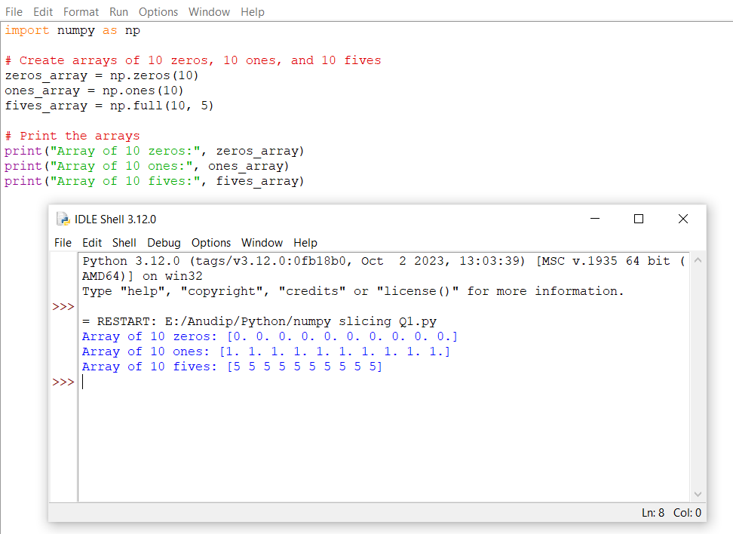

**2. Write a NumPy program to create a 3x3 matrix with values ranging from 2 to 10.**

**Sol:**

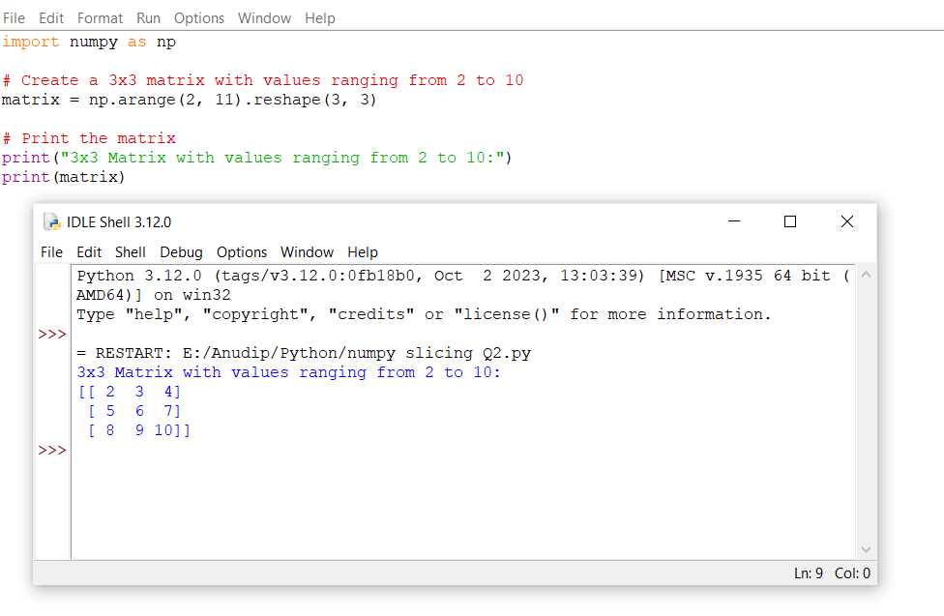

**3. Write a NumPy program to create an array with values ranging from 12 to 38.**

**Sol:**

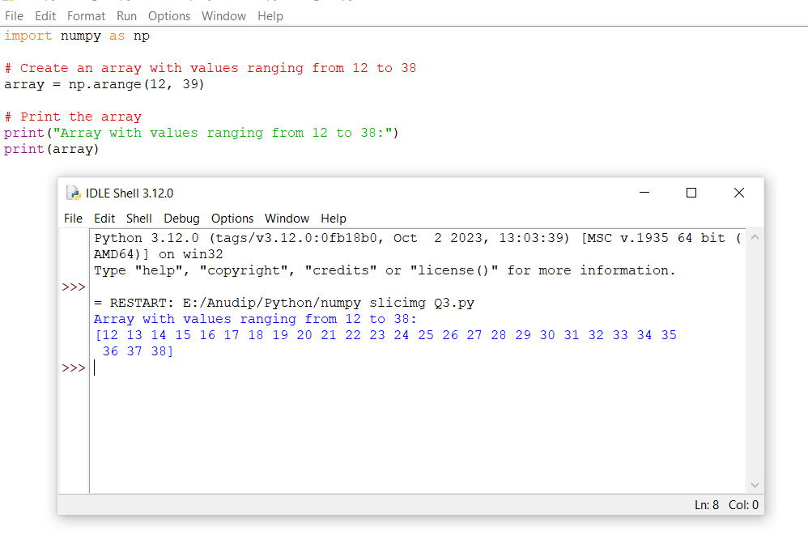

**4. Write a NumPy program to convert a list and tuple into arrays. Input: my_list = [1, 2, 3, 4, 5, 6, 7, 8] Input: my_tuple = ([8, 4, 6], [1, 2, 3])**

**Sol:**

